**Basic Plot Types: Geoms**

Geoms are the fundamental building blocks of ggplot2, useful in their own right, and in conjunction to make more complex plots.  
  
geom_area : draws an area plot  
geom_bar : bar-chart  
geom_line : produces a line plot  
geom_point : produces a scatter plot.  
geom_polygon: draws polygons, which are filled paths.  
geom_text :   add labels at the specified points  
geom_tile :   makes an image plot or level plot.

|  |
| --- |
| > P <- ggplot(iris,aes(Sepal.Length,Sepal.Width))  + xlab(NULL) + ylab(NULL)  >  > P + geom_point(colour="navyblue")  + opts(title ="Iris Scatterplot") |

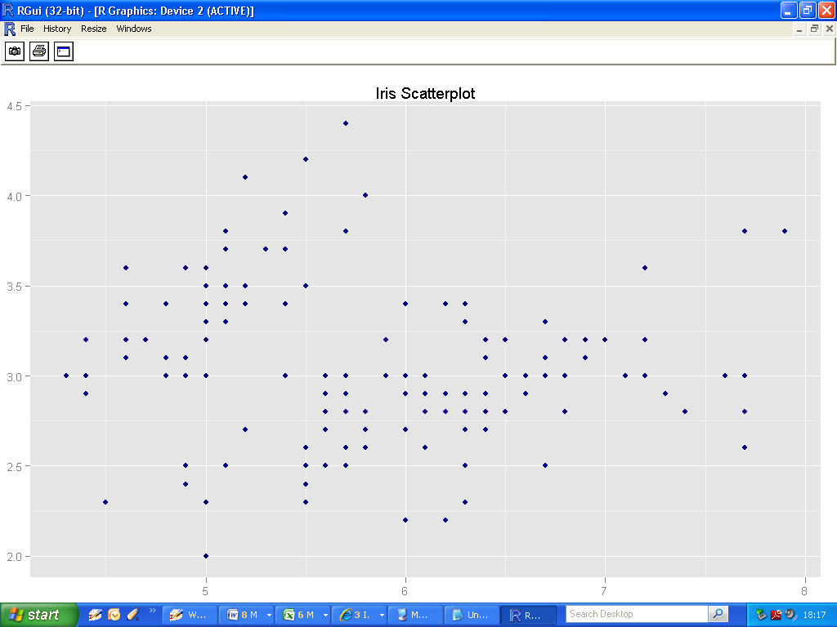

* Navy blue glyphs
* No axes labels
* Title on plot (“Iris Scatterplot”)

## 5.2 Overall Layering strategy

1. to display data
2. to display a statistical summary of the data
3. to add additional metadata, context and annotations

## 5.3 Basic Plot Types

|  |
| --- |
| df <- data.frame(  x = c(3, 1, 5),  y = c(2, 4, 6),  label = c("a","b","c")  )  p <- ggplot(df, aes(x, y, label = label)) +  xlab(NULL) + ylab(NULL)  p + geom_point() + opts(title = "geom_point")  p + geom_bar(stat="identity") +  opts(title = "geom_bar(stat=\"identity\")")  p + geom_line() + opts(title = "geom_line")  p + geom_area() + opts(title = "geom_area")  p + geom_path() + opts(title = "geom_path")  p + geom_text() + opts(title = "geom_text")  p + geom_tile() + opts(title = "geom_tile")  p + geom_polygon() + opts(title = "geom_polygon") |

## 5.4 Displaying distributions

|  |
| --- |
| Depth_dist +  Geom_histogram  Depth_dist + geom_histogram(aes(fill=cut),binwidth =0.1,position =”fill”) |

## 5.5 Dealing with overplotting

## Narrower glyphs

## Jitter

* Alpha blending

## 5.6 Surface plots

* Ggplot2 does not support 3d graphics.
* However it does support ways of presenting 3d surfaces in 2d: contour plots, coloured tiles and bubbleplots.

## 5.7 Map Data

Ggplot2 has incorporated some tools that make it easy to combine maps into projects, for example the borders () function.

## 5.8 Revealing uncertainty

|  |  |  |
| --- | --- | --- |
| X variable | Range | Range + Centre |
| Continuous | geom_ribbon | geom_smooth(stat=”identity”) |
| Discrete | geom_errorbar | geom_crossbar |
|  | geom_linerange | geom_pointrange |